Setup for Day 3 of the FDP
The generative system: RAG, LLMOps and AgentOps

Session 1: RAG
Prerequisite: Check Python version using command “python --version”. It is preferable to have a runtime higher than python version 3.10.

Step 1: Create a Python Virtual Environment
- Open VS Code & Go to Terminal
- Command - “python -m venv .venv”

Step 2: Activate the Virtual Environment [Type in the Terminal]
- Command - “.\.venv\Scripts\Activate.ps1”
Step 3: Create RAG Project folder structure
The participants should create the following code structure in Visual Studio Code.
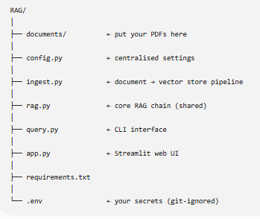
Note
1. In the “documents” folder, you can upload the PDF documents of your lecture content. Suppose you are teaching course “X”, convert all the PPTs to PDF and upload. You can also upload the Transcripts generated from MS Teams by converting them to PDF.
2. The contents for other code will be provided during the workshop.

Step 4: Copy paste the following lines inside the “.env” file
OPENAI_API_KEY=your_openai_api_key
OPENAI_MODEL=gpt-4o-mini
OPENAI_EMBEDDING_MODEL=text-embedding-3-small
RETRIEVAL_K=5

Step 5: Contents of “requirements.txt” file [Just copy paste the contents in the requirements.txt file]
langchain==0.3.25
langchain-community==0.3.24
langchain-openai==0.3.16
langchain-chroma==0.2.4
chromadb>=1.0.9
pypdf==5.4.0
pymupdf==1.25.5
openai==1.70.0
python-dotenv==1.1.0
streamlit==1.44.1
tiktoken==0.9.0

Step 6: Install all required dependencies [Type in the terminal]
- Command – “pip install -r requirements.txt”
We are ready to go for the first session!

Session 2: LLMOps
Step 1: Create a Python Virtual Environment
- Open VS Code & Go to Terminal
- Command - “python -m venv .venv”

Step 2: Activate the Virtual Environment [Type in the Terminal]
- Command - “.\.venv\Scripts\Activate.ps1”

Step 3: Create the RAG / LLMOps Project folder structure
The participants should create the following code structure in Visual Studio Code.
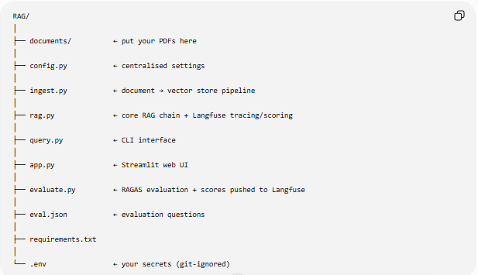
Note
1. In the “documents” folder, you can upload the PDF documents of your lecture content. Suppose you are teaching course “X”, convert all the PPTs to PDF and upload. You can also upload the Transcripts generated from MS Teams by converting them to PDF.
2. The contents for other code will be provided during the workshop.

Step 4: Copy paste the following lines inside the “.env” file
OPENAI_API_KEY=your_openai_api_key
OPENAI_MODEL=gpt-4o-mini
OPENAI_EMBEDDING_MODEL=text-embedding-3-small
RETRIEVAL_K=5
LANGFUSE_PUBLIC_KEY=your_langfuse_public_key
LANGFUSE_SECRET_KEY=your_langfuse_secret_key
LANGFUSE_HOST=https://cloud.langfuse.com

Step 5: Contents of “requirements.txt” file [Just copy paste the contents in the requirements.txt file]
langchain==0.3.25
langchain-community==0.3.24
langchain-openai==0.3.16
langchain-chroma==0.2.4
chromadb>=1.0.9
pypdf==5.4.0
pymupdf==1.25.5
openai==1.70.0
python-dotenv==1.1.0
streamlit==1.44.1
tiktoken==0.9.0

# Observability
langfuse>=3.3.0,<4.0.0

# RAG evaluation
ragas==0.4.3

Step 6: Install all required dependencies [Type in the terminal]
- Command – “pip install -r requirements.txt”

We are ready to go for the second session!

